1. **The questions I want to figure out**

Dota2 is a very popular game across the world and the annual tournament The International (TI) attracts all Dota fans and players’ focus.

When I was watching this year’s TI,which is TI10, comments in the stream live drew my attention: **“Oh that team’s draft (hero picking) is so boring, always similar and no creativity, they won’t go far like this.”** I started to wonder, is that true? Then I started this project.

Also, the game has released for more than 10 years and its number of average players is keep on declining, some media even refer it as “a dead game”, I would also like to propose my idea,though trivial, to help the game that I love.

Finally, I would also like to introduce the game and this fantastic tournament to a wider community. Looking forward to seeing you joining us as a TI viewer next year!

1. **Data collecting**

Mainly the data was collected from open-source DOTA2 platforms such as Opendota, Dotabuff by SQL queries and BI request.

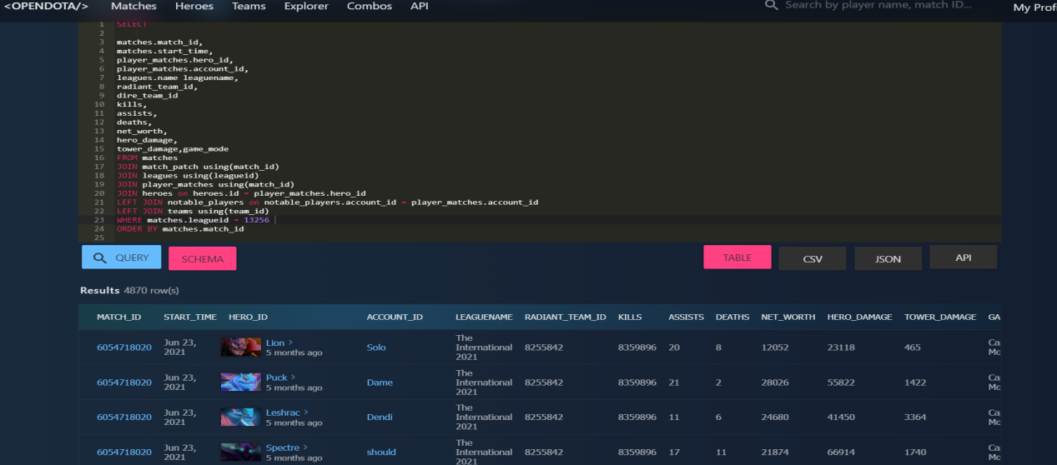

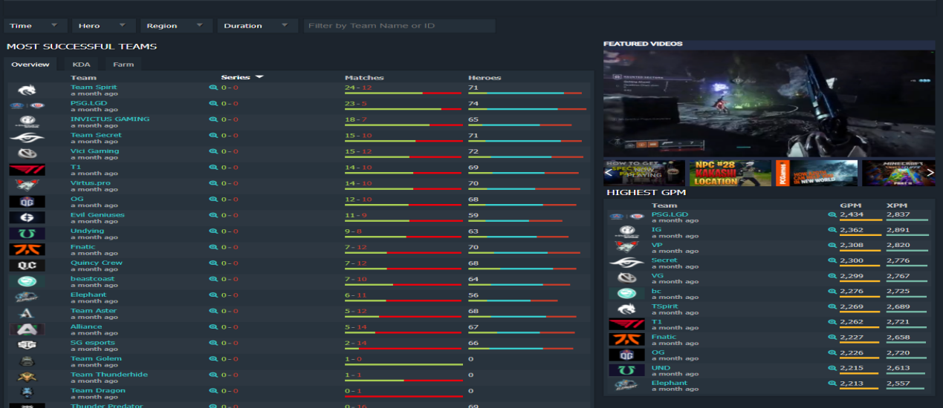

1. **Data Cleaning**

This process actually takes the most of the time of my project. Tens of thousands of raw data gathered was grouped and sorted via Excel,MYSQL, and BI. Also, many new indicators were created based on the data to better review various details of this tournament and the performance from heroes,teams perspectives.

**MYSQL**

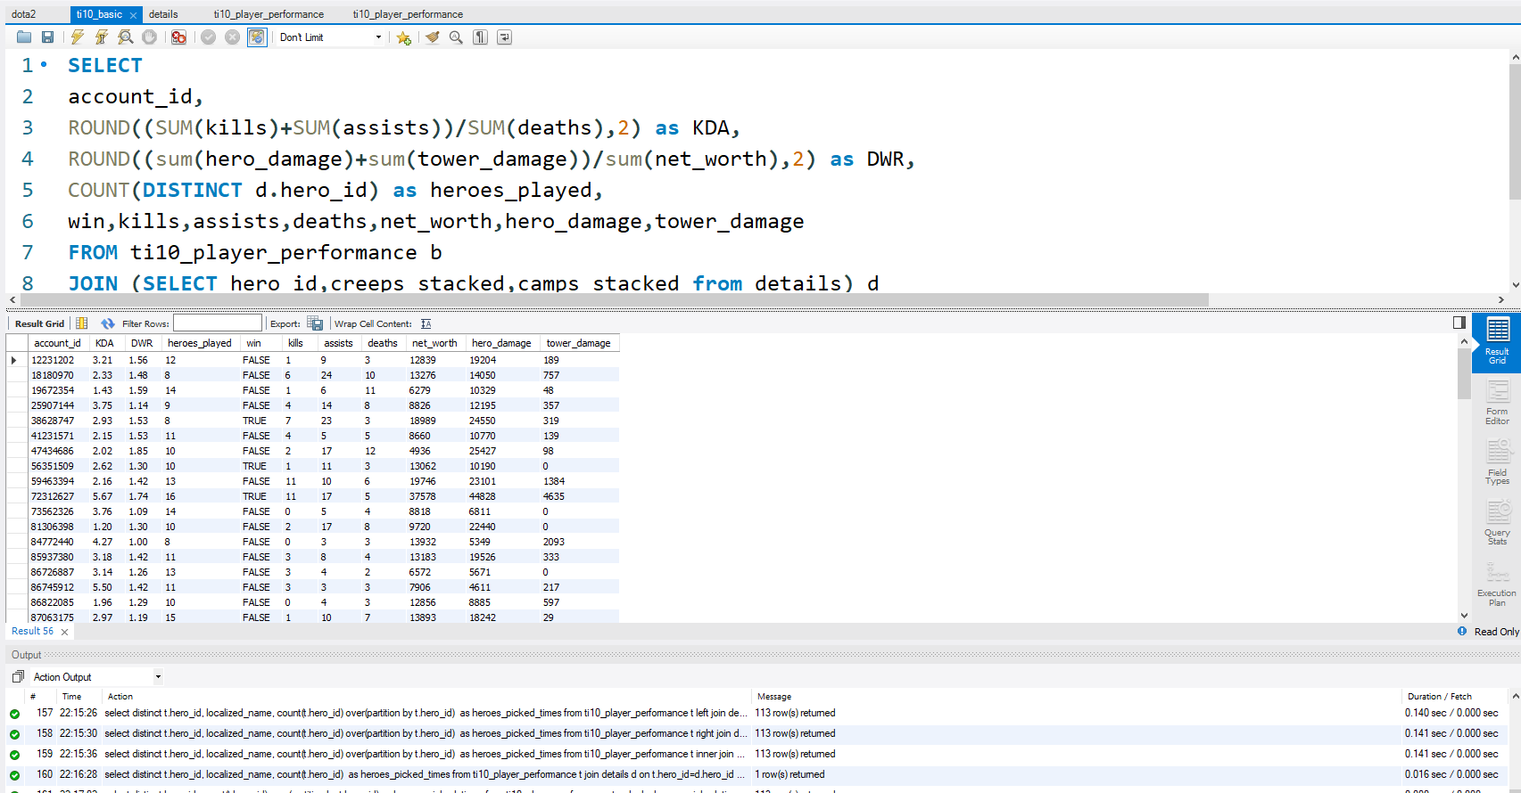

**Excel**

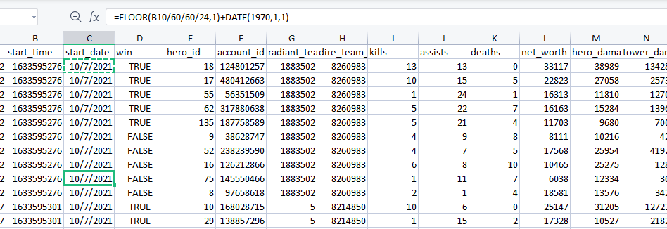

**BI**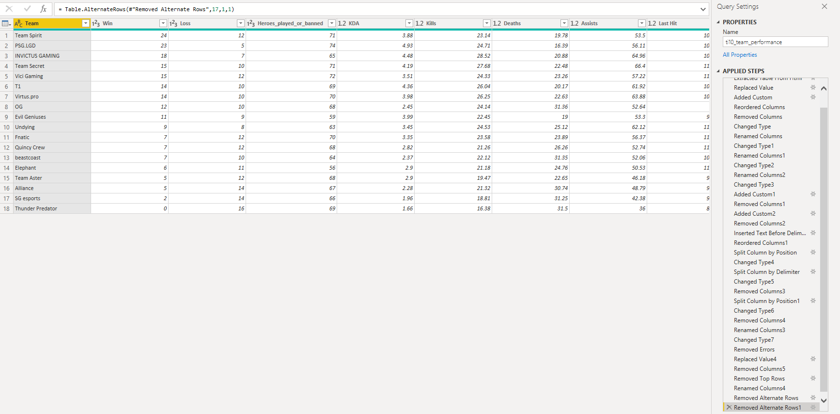

1. **Data Analyse and Visualization**

This project is being made into three parts, a general introduction to Dota2 & The International, and an analysis from teams and heroes perspectives. Also, a conclusion to these two parts is included.

Without further ado, please take a look at it and feel free to ask me any questions!

1. Data Source References:

<https://steamcharts.com/app/570>

<https://www.dotabuff.com/esports/leagues/13256-the-international-2021>

<https://www.opendota.com/api-keys>